CUSTOMER CHURN REDUCTION ANALYSIS
End-to-End Business Analysis Case Study on the Olist Brazilian E-Commerce Dataset
Business Analyst Portfolio Project
Source data: Olist Brazilian E-Commerce Public Dataset (Kaggle) · 2016-09 – 2018-08 · 96,353 delivered orders
This report is based on SQL queries run against a real, publicly available dataset and Excel dashboard findings derived from them. The company name, stakeholder names, and meeting notes are fictional; all numerical findings are real.

1. Problem Statement
ShopBR is a mid-sized Brazilian e-commerce platform that connects multiple sellers in a single marketplace. Management noticed that the customer dissatisfaction rate (1–2 star reviews) rose from around 10% to 19–21% between November 2017 and March 2018. During the same period, the late delivery rate climbed to 14–21%. Management asked the Business Analyst to identify the root causes of this dissatisfaction spike, pinpoint which product categories, regions, and operational processes it concentrates in, and provide concrete, data-driven recommendations for mitigation.
Scope note: Upon examining the data, it became clear that 96.9% of customers on this marketplace placed only a single order. This makes a classic "no repeat purchase = churn" analysis nearly meaningless for this dataset (see Section 5). The project scope was therefore reframed — jointly with the business sponsor — as "risk of customer dissatisfaction and loss of brand trust." This is a common scope-clarification step in real BA projects and is reflected in the stakeholder notes below.

3. Requirements Document (BRD / FRD Draft)

3.1 Business Requirements (BRD)
ID | Requirement | Source
BR-01 | Show the trend of the dissatisfaction rate increase over time. | Marketing Manager
BR-02 | Identify where dissatisfaction concentrates at the regional (state) level. | Marketing Manager
BR-03 | Identify where dissatisfaction concentrates at the product category level. | Product Manager
BR-04 | Quantitatively prove the relationship between delivery delays and customer satisfaction. | Operations
BR-05 | Examine the effect of payment type on customer behaviour. | Customer Service
BR-06 | Present findings in a dashboard that management can review easily. | General Manager

3.2 Functional Requirements (FRD)
ID | Functional Requirement
FR-01 | The system must be able to group orders by month and calculate dissatisfaction and late-delivery rates.
FR-02 | The system must be able to rank categories with at least 200 orders by dissatisfaction rate.
FR-03 | The system must be able to rank states with at least 300 orders by dissatisfaction rate.
FR-04 | The dashboard must auto-refresh when new data is added without changing any filters (live formulas).
FR-05 | The analysis must produce a single unified view from raw data (orders, customers, payments, reviews, products).

3.3 Data Requirements
- olist_orders_dataset — order status, purchase / estimated / actual delivery dates
- olist_customers_dataset — customer ID (customer_unique_id) and state
- olist_order_reviews_dataset — review score (1–5)
- olist_order_payments_dataset — payment type
- olist_order_items_dataset + olist_products_dataset + product_category_name_translation — category information

4. Process Flow (BPMN)
The table below summarises the customer journey from purchase → delivery → (complaint or satisfaction) → (repeat purchase or churn risk). A visual BPMN diagram is included separately in the project presentation.
Step | Process | Description / Decision Point
1 | Order placement | Customer selects product and chooses payment method.
2 | Shipping / delivery | Order is dispatched; actual delivery date compared against estimated date.
3 | Decision: On time? | If actual delivery date > estimated date, order is flagged as "late" (8.0% of orders in the dataset).
4a | On time → High review score | Average score 4.29/5 (see Section 5).
4b | Late → Complaint / low score | Average score 2.57/5 — a strong, statistically significant difference.
5 | Outcome | High score → brand trust and possible return visit; low score → dissatisfaction and churn risk.

5. Data Analysis with SQL
The queries below were actually executed against a SQLite database built from the Olist dataset; all results come from real data (syntax is close to standard ANSI SQL; date functions are SQLite-specific).

5.1 Repeat Purchase Rate — Testing the Churn Definition
SELECT c.customer_unique_id, COUNT(DISTINCT o.order_id) AS order_count
FROM orders o JOIN customers c ON o.customer_id = c.customer_id
WHERE o.order_status = 'delivered'
GROUP BY c.customer_unique_id;
Result: Only 3.00% of 93,358 unique customers placed more than one order. This confirms that the classic "no repeat purchase = churn" definition is not meaningful in this marketplace model → the analysis was reframed to focus on the dissatisfaction rate (review ≤ 2).

5.2 Impact of Late Delivery on Satisfaction
SELECT CASE WHEN julianday(order_delivered_customer_date) >
julianday(order_estimated_delivery_date) THEN 1 ELSE 0 END AS late_flag,
AVG(review_score) AS avg_score
FROM orders o LEFT JOIN order_reviews r ON o.order_id = r.order_id
WHERE o.order_status = 'delivered' GROUP BY late_flag;
Delivery Status | Average Review Score
On time (92.0%) | 4.29 / 5
Late (8.0%) | 2.57 / 5
Average delay for late orders: 9.4 days. This finding shows that delivery performance is the single strongest predictor of customer satisfaction.

5.3 Monthly Dissatisfaction Trend (Recent Period)
SELECT strftime('%Y-%m', order_purchase_timestamp) AS month,
ROUND(100.0*SUM(CASE WHEN review_score<=2 THEN 1 ELSE 0 END)/COUNT(*),2) AS rate
FROM orders o JOIN order_reviews r ON o.order_id=r.order_id
WHERE o.order_status='delivered' GROUP BY month ORDER BY month;
Result: The dissatisfaction rate rose to 16.6% in Nov 2017, 19.3% in Feb 2018, and peaked at 21.2% in Mar 2018, then gradually declined to 9.5% by Aug 2018 (see Section 6, Monthly Trend chart). This suggests that an operational improvement — likely the normalisation of carrier capacity — took effect.

5.4 Category and State Breakdown
SELECT category, COUNT(*) n, AVG(review_score) avg_score,
100.0*SUM(CASE WHEN review_score<=2 THEN 1 ELSE 0 END)/COUNT(*) dissatisfaction_rate
FROM orders_join_products
GROUP BY category HAVING n >= 200 ORDER BY dissatisfaction_rate DESC LIMIT 10;
Top dissatisfaction categories: office_furniture (21.9%), audio (21.6%), and home_confort (18.1%) — all large-volume or fragile product groups, consistent with the product manager's "shipping damage" hypothesis. By state, AL (21.4%), MA (19.8%), and SE (18.9%) have the highest dissatisfaction rates — all geographically distant from the São Paulo / Rio axis (the main logistics hubs), located in the north/northeast of Brazil (see Section 6 tables).

5.5 Payment Type Breakdown
Customers paying with vouchers showed a repeat purchase rate of 10.1%, notably higher than credit card users (6.4%) — a secondary finding suggesting that coupon/discount campaigns may be the most powerful tool for driving return visits.

6. Power BI Alternative: Excel Dashboard
As Power BI was not available, an Excel dashboard was built using live SUMIFS / COUNTIFS / AVERAGEIFS formulas (see attached Musteri_Kaybi_Analizi_Dashboard.xlsx). Raw data is kept on a "Raw_Data" sheet; all summary tables and charts are fed from it via live formulas — meaning the entire dashboard auto-recalculates whenever the raw data is updated.

6.1 Executive Summary
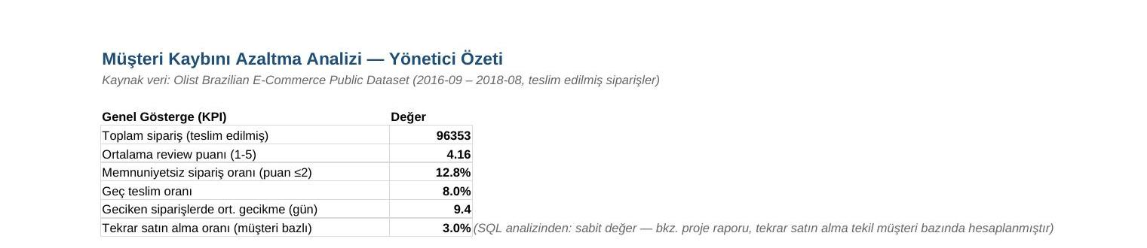

6.2 Monthly Trend
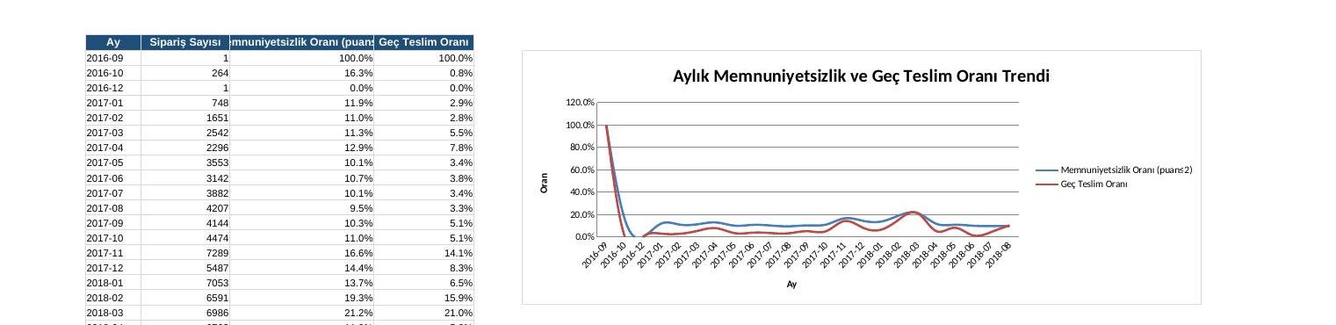
Clear spike in dissatisfaction and late deliveries from Nov 2017 to Mar 2018, followed by improvement.

6.3 Category Breakdown
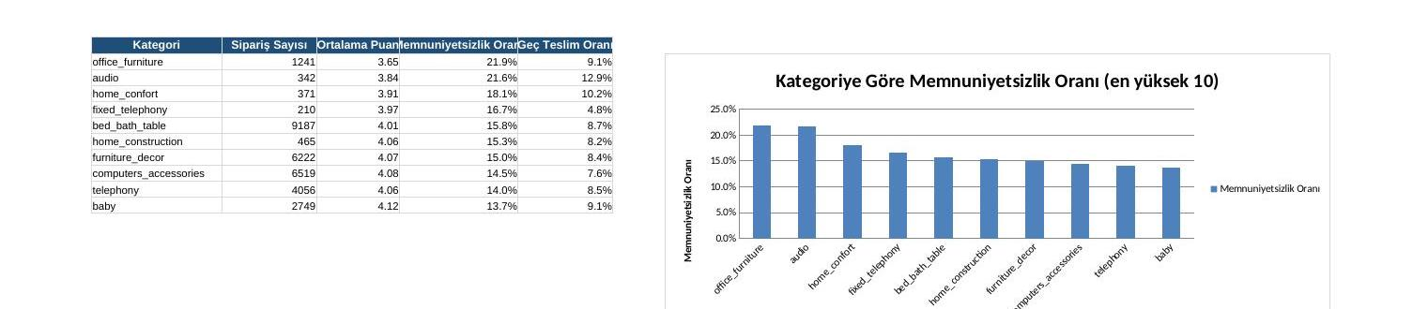

6.4 State Breakdown
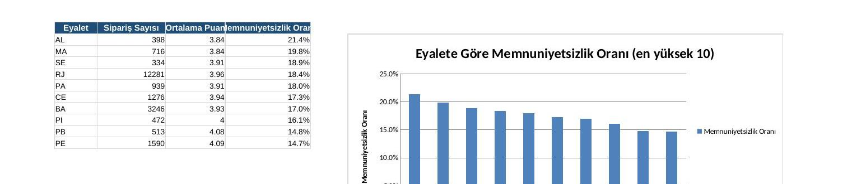

6.5 Payment Type Analysis
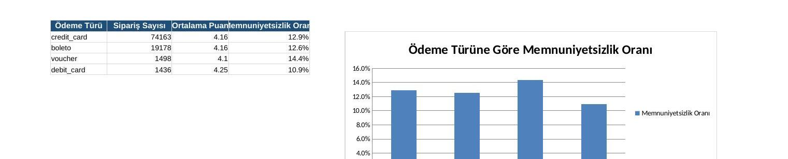

7. Agile Approach
The project was managed using a Scrum cycle of three 2-week sprints:
Sprint 1 — Discovery & Data Preparation
- Stakeholder interviews and completion of the requirements document
- Data source validation, cleaning, and loading into SQLite
- User story: "As a Business Analyst, I want to join raw order / customer / review data into a single table so that all subsequent analyses draw from a consistent source."
Sprint 2 — Analysis & Root Cause
- Writing SQL queries and testing churn/dissatisfaction hypotheses
- Extracting category, state, and payment-type breakdowns
- User story: "As a customer service rep, I want to see complaint reasons broken down by category so I know which product groups to prioritise."
- User story: "As an operations manager, I want to see the relationship between delivery delay and review score so I can prioritise cargo SLAs."
Sprint 3 — Dashboard & Presentation
- Building the Excel dashboard (live formulas + charts)
- Summarising findings and recommendations for the management presentation
- User story: "As a General Manager, I want to see the dissatisfaction trend on a single screen so I can make quick decisions."
Sprint retrospective: The biggest learning was that the initial assumption (no repeat purchase = churn) was not supported by the data, and the scope had to be reframed with the stakeholder at the end of Sprint 1 — a real-world application of Agile's "early and frequent feedback" principle.

8. Conclusions & Recommendations
The analysis showed that the classic "no repeat purchase" churn definition does not apply to this marketplace model. The real risk is dissatisfaction (low review score), driven primarily by delivery performance. Four concrete recommendations follow:
1. Tighten cargo SLAs and prioritise high-risk regions
Late delivery drops the average review score from 4.29 to 2.57 — a single operational metric with outsized impact. SLAs with logistics partners in states such as AL, MA, SE, and RJ should be reviewed, and capacity increases (especially during campaign periods) should be planned proactively.
2. Raise packaging standards for fragile and large-volume categories
In office_furniture, audio, and home_confort, the dissatisfaction rate is 18–22%, well above the platform average of 12.8%. A dedicated packaging and damage-prevention guide should be prepared for sellers in these categories.
3. Add a structured complaint category field
As Customer Service noted, complaints are currently stored only as free text. Adding a structured field to the review form — e.g. "delay / damage / wrong item / other" — would make future root-cause analyses significantly faster and more reliable.
4. Scale up voucher/coupon campaigns as a loyalty tool
Voucher-paying customers have a repeat purchase rate roughly 1.6× higher than credit card users. Sending a targeted next-order coupon to customers who experienced a dissatisfying delivery is a low-cost action that could meaningfully reduce churn risk.

